*Florida International University*

*School of Computing and Information Sciences*

CIS 4911 - Senior Capstone Project

Software Engineering Focus

Feature Document

User Story #730

**Team Member:**

Andrew Mitchell

**Product Owner(s)**:

Francisco R. Ortega

**Mentor(s)**:

Francisco R. Ortega

...

**Instructor**: Masoud Sadjadi

**User Story –** Implement Icons

* As a User I would like nice and obvious icons to Quickly tell what a buttons functionality is.

Acceptance Criteria

* Implement Icons from Iconfinder into the program.

**Use Case #730 – View User Interface**

Use Case

User launches application and views the user interface. If the eyeX is connected you may have to gaze to see certain menus.

Details:

Actor: User

Pre-conditions:

Program must be running.

Description:

Use case begins when the user starts up the program. They can then view the user interface and see the various icons that represent different functionality for buttons.

Post-conditions:

The icons should look presentable and it should be fairly obvious what they do.

Decision Support:

Frequency: Almost always. Whenever the user uses an element of the UI they will see the various icons.

Criticality: High. Icons are important for a program so it is easy to use and intuitive.

Risk: Medium. Implementing icons are something we have not done before, so it may cause some unexpected bumps.

Reliability: Highly.

Mean time to Failure – N/a.

Availability – Depends on if the UI is turned on or not.

Performance:

Should have very lower performance impact.

Supportability:

Entire Program and all devices.

Supported by LibUSB – version 1.0

Modification History:

Owner: Andrew Mitchell

Initiation date: 4/18/2016

Date last modified: 4/27/2016

**Use Case Diagram**

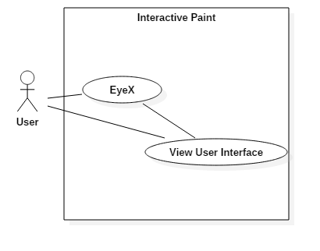

**Sequence Diagram**

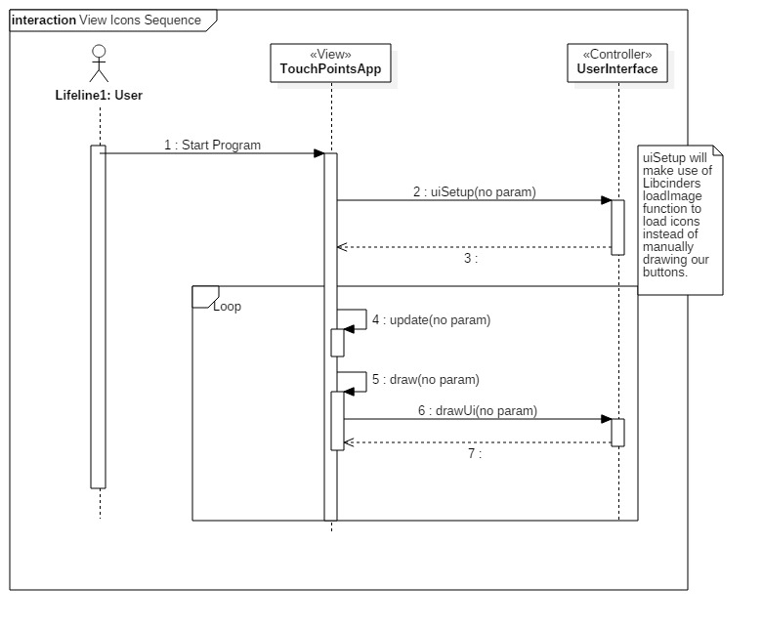

**Class Diagram**

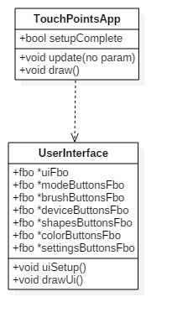

**Unit Test**

Sunny Day:

Test Case: EyeX UI Icons.

Test Purpose:

Ensure the program uses the icons when the EyeX enables or disables certain elements of the UI.

Test Setup

1. Start Program with EyeX
2. Gaze at the top left
3. Gaze at the bottom right
4. Gaze at the top left.

Test Output:

When I looked at the top left I could see all the icons. Looking at the bottom right I could see the mode box (and settings button).

Expected Output:

Gazing to the top left should enable the mode buttons to turn on as well as display some of the new icons.

The bottom right gaze you should be able to see the settings button inside the mode box.

Rainy Day Tests:

Test Case: Rapid Circle Drawing Leap

Test Purpose:

Make sure the buttons and icons reappear when we turn off and on the UI with the Radial Menu.

Test Setup:

1. Have multitouch plugged in.
2. Double tap to pull up radial menu.
3. Tap the bottom button
4. Tap the bottom button

Test Output:

Ui turned off at step 3.

Ui and all icons turned back on step 4.

Expected Output:

After tapping the button twice the icons should still be visible (not just empty boxes).

**Integration Test**

Currently new icons are implemented for the Multitouch interactions.

The ‘Mode Buttons’ in the top left now have new icons for the most part.

The Mode box has a new ‘settings’ icon in the bottom left.

Currently works with any UI turning on or off (Using EyeX or Radial menu).

**User Guide**

You can see the new icons in the image below. We have new icons to represent brush modifications, a button to represent changing shapes, an eraser icon and more!

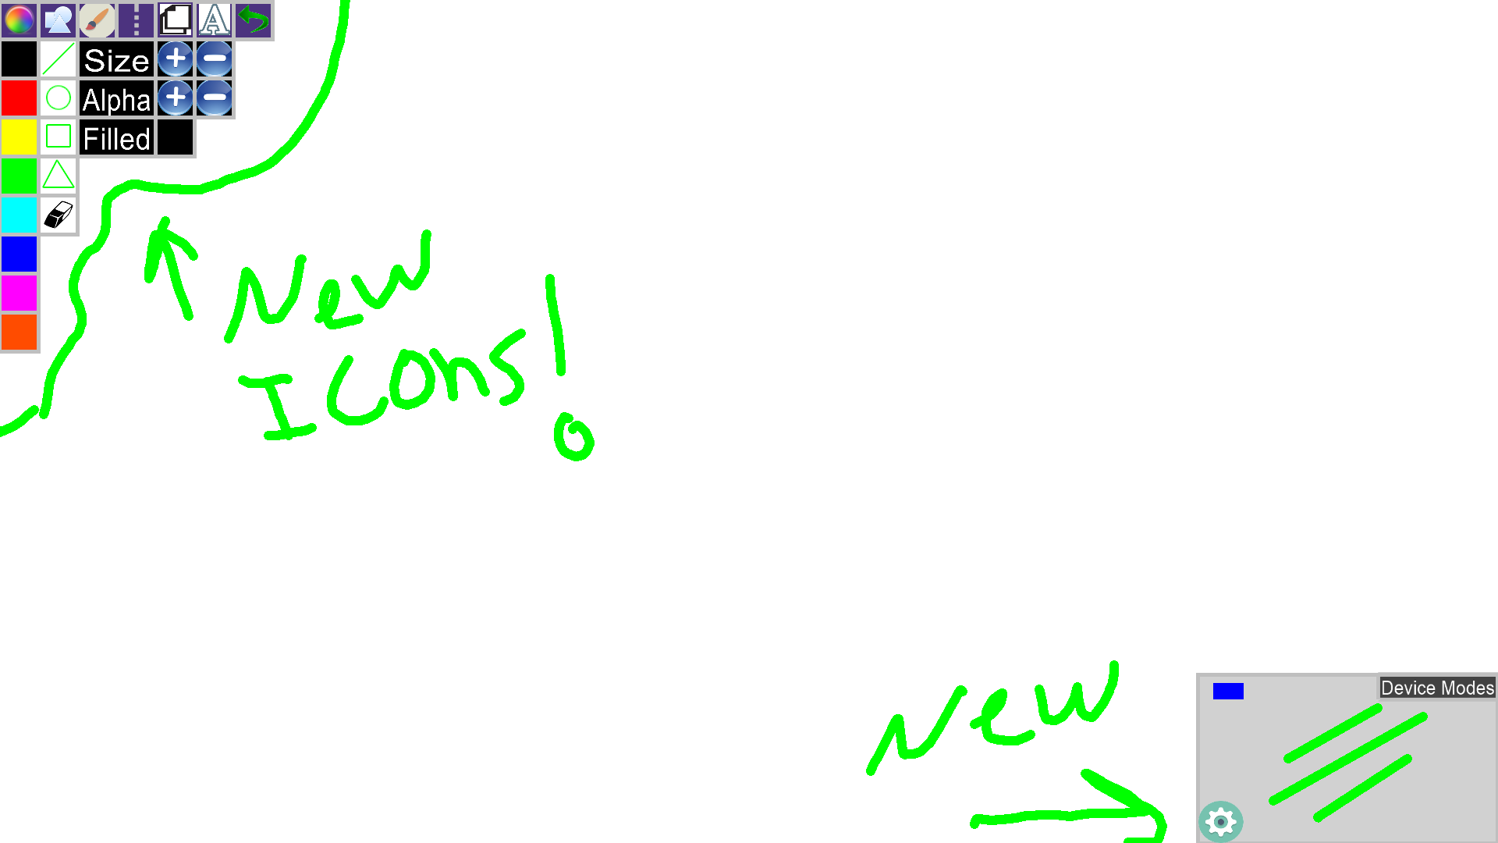

**Glossary**

N/a